

Milano (Thailand)


vdalve
One Piece Toilet
CL20415-6DACTCB

FEATURES
- Contemporary design
- Double Vortex washdown
- Rimless
- Wider Seat & Cover with comfort curve and slow-closing
- ComfortClean Glaze
- Water Saving: 3/4.2L Dual flush

SPECIFICATIONS
- Flushing Platform: Double Vortex Wash Down
- Flushing Type: Dual flush / Top push
- Litres Per Flush: 3/4.2 lpf
- S/P-Trap: S trap & P trap
- Roughing in: 305mm floor discharge/190mm wall discharge
- Bowl Shape: Elongate
- Overall Dimensions (LxWxH):
L760xW422xH707mm
- Height to Rim: 390mm
- Material: Vitreous China
- Color: White only (6D)

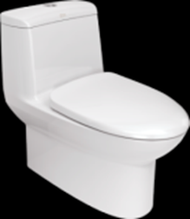

INCLUDED COMPONENTS
- Slow closing seat
- Dual tank fitting set
- Connector
- Floor fixing set
- Stop valve
- Installation manual

SHIPPING WEIGHT AND DIMENSIONS
- Gross Weight: 64.07 kg
- Net Weight: 53 kg

STANDARDS CRITERIA
- TIS-792:2011
- PNS 156:2010
- MS 1522:2011
- SS 378-1996
- ASME-A112.19.2-2013
- SNI 03-0797-2006

DIMENSIONAL DRAWING

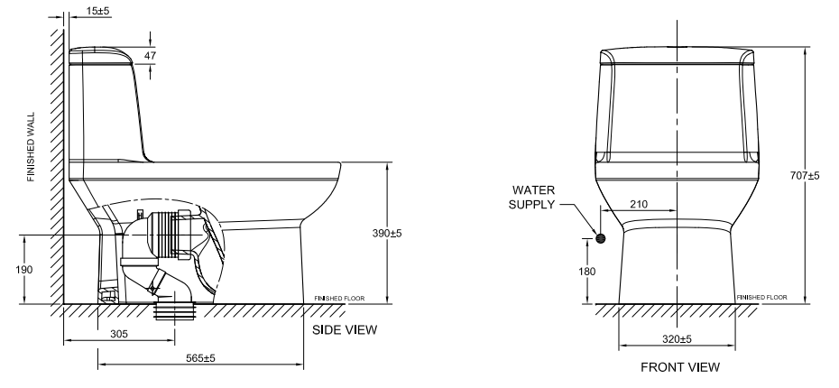

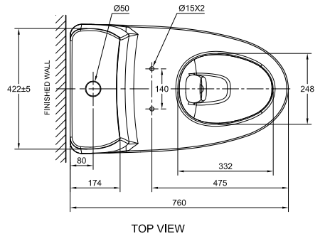

This document is the property of American Standard. It can neither be reproduced, nor communicated, without authorization.
American Standard reserves the right to change dimensions and specifications without notice; we assume no liability for the use of obsolete dimensions.

