

Signature


Concealed Shower only Mixer
FFFAS1722-709500BC0

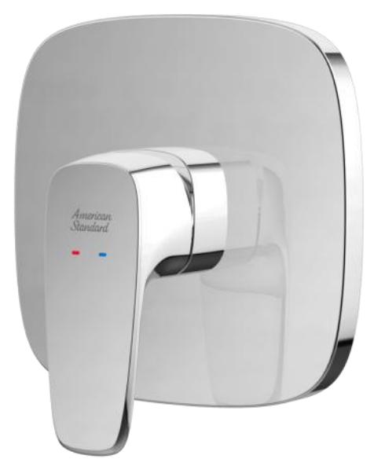

FEATURES

- DZR brass, strong and durable
- High quality ceramic valve for longer usage
- Ceramic cartridge tested = 500,000 times
- Without shower kits
- With normal packaging
- Flow rate @ 0.1MPa: 13.5 L/min for shower outlet

SPECIFICATIONS

Concealed Shower only Mixer
In-wall installation
Escutcheon size: 150X150mm

FINISHES AVAILABILITY
DIMENSIONAL DRAWING

Chrome (- CP)

AWARDS WON
- N/A

SHIPPING WEIGHT
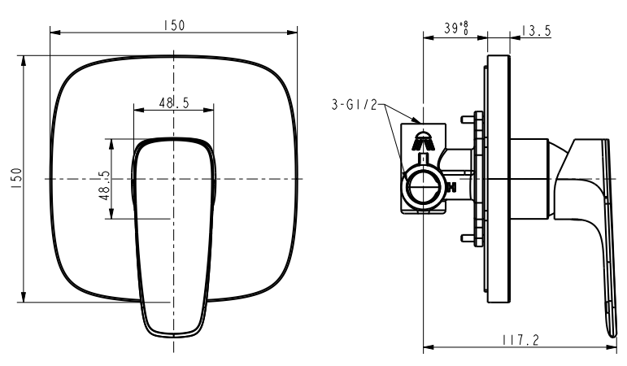
Product gross weight: 1.35kg/set
Product net weight: 1.07 kg/set

STANDARDS CRITERIA
GB 18145-2014

This document is the property of American Standard. It can neither be reproduced, nor communicated, without authorization.
American Standard reserves the right to change dimensions and specifications without notice, we assume no liability for the use of obsolete dimensions.

