

Signature

Exposed Shower Mixer
FFAS1712-709500BC0

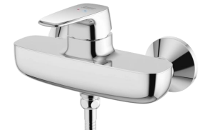

FEATURES

- A grade brass, strong and durable
- Grohe High quality ceramic valve for longer usage
- Ceramic cartridge tested = 500,000 times
- Without shower kits
- With normal packaging
- Flow rate @ 0.1MPa: 16 L/min for shower outlet

SPECIFICATIONS
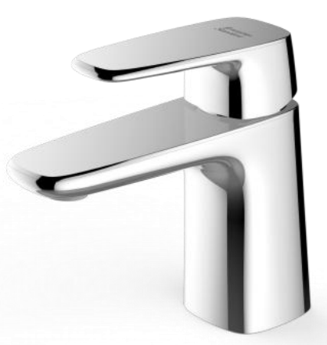
Exposed Bath & Shower Mixer Faucet
2-Hole Installation: lever handle (cold & hot)

DIMENSIONAL DRAWING

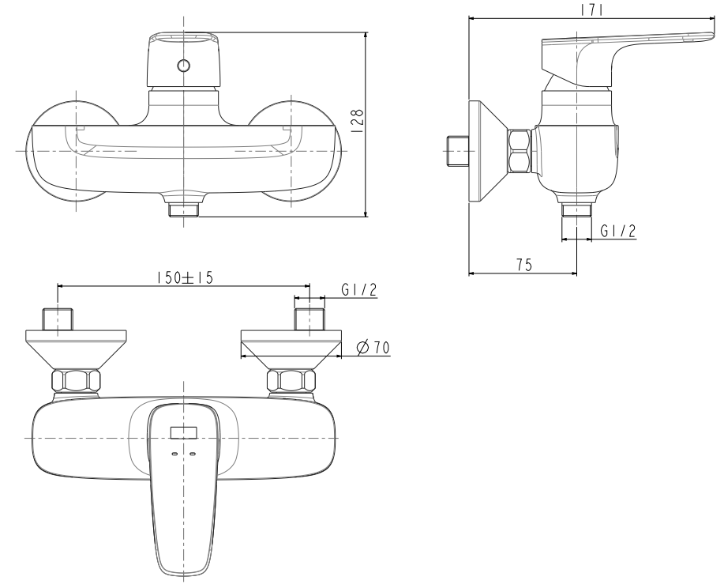
FINISHES AVAILABILITY

Chrome (- CP)

AWARDS WON
- N/A

SHIPPING WEIGHT
Product gross weight: 2.26kg /set
Product net weight: 2.132kg /set

STANDARDS CRITERIA
GB 18145-2014

This document is the property of American Standard. It can neither be reproduced, nor communicated, without authorization.
American Standard reserves the right to change dimensions and specifications without notice, we assume no liability for the use of obsolete dimensions.

