

Signature

Single Hole Basin Mixer with Pop-up Drain
FFAS1701-1015L0BC0

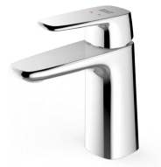

FEATURES

- Low lead brass, strong and durable
- Grohe High quality ceramic valve for longer usage
- Ceramic cartridge tested = 500,000 times
- Neoperl aerator PCA 1.5 GPM
- With pop-up drain
- With normal packaging
- Flow rate @ 0.1MPa: 4 L/min

SPECIFICATIONS
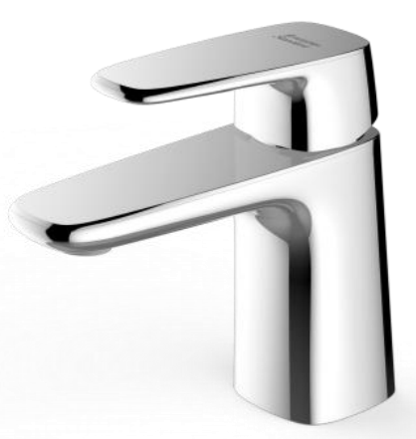
Basin mixer faucet
1-hole installation: lever handle (cold & hot)
Spout reach: 100.8 mm
Spout height: 98.5 mm

DIMENSIONAL DRAWING

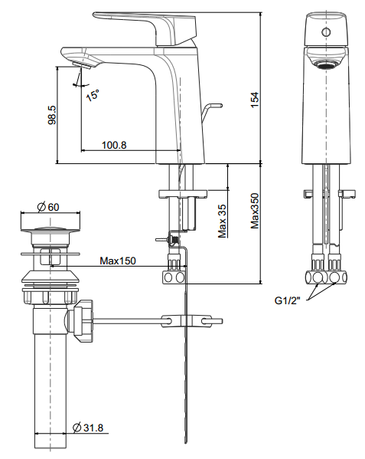
FINISHES AVAILABILITY

Chrome (- CP)

AWARDS WON
- N/A

SHIPPING WEIGHT
Product gross weight: 1.842kg /set
Product net weight: 1.634kg /set

STANDARDS CRITERIA
GB 18145-2014
TIS 2067-2552

This document is the property of American Standard. It can neither be reproduced, nor communicated, without authorization.
American Standard reserves the right to change dimensions and specifications without notice, we assume no liability for the use of obsolete dimensions.

